# Business Understanding

1. What is the business problem that you are trying to solve?

When requesting for a loan in a bank, we want to showcase the risk factor of providing loan to the applicant and The main objective is to develop a predictive model to categorize credit applicants into different risk levels

2. What data do you need to answer the above problem?

We want the data set of different customer and their loan repayment status history with their financial attributes

3. What are the different sources of data?

Data retrieved is from public website called kaggle. The dataSet has records from different bank entities/SSN.

4. What kind of analytics task are you performing?

Credit Risk Assessment : We are evaluating the creditworthiness of individuals or customers based on their credit history, payment behavior, outstanding debts, credit utilization ratio, and other relevant factors

# Data Acquisition

## Download the data directly

In [72]:

*##---------Type the code below this line ##*

**!**pip install opendatasets **import** pandas **as** pd **import** os

**import** opendatasets **as** od

**import** warnings

*# warnings.filterwarnings('ignore', category=pd.core.common.SettingWithCopyWarning)*

"""

To download from kaggle, we need kaggle.json file in the present directory. it will download into a directory c """

dataset_url **=** ['https://www.kaggle.com/datasets/parisrohan/credit-score-classification'](http://www.kaggle.com/datasets/parisrohan/credit-score-classification%27) od**.**download(dataset_url)

os**.**listdir('credit-score-classification')

Requirement already satisfied: opendatasets in /Users/bashok826/anaconda3/lib/python3.10/site-packages (0.1.22) Requirement already satisfied: kaggle in /Users/bashok826/anaconda3/lib/python3.10/site-packages (from opendata sets) (1.6.6)

Requirement already satisfied: tqdm in /Users/bashok826/anaconda3/lib/python3.10/site-packages (from opendatase ts) (4.64.1)

Requirement already satisfied: click in /Users/bashok826/anaconda3/lib/python3.10/site-packages (from opendatas ets) (8.0.4)

Requirement already satisfied: certifi in /Users/bashok826/anaconda3/lib/python3.10/site-packages (from kaggle-

>opendatasets) (2023.5.7)

Requirement already satisfied: requests in /Users/bashok826/anaconda3/lib/python3.10/site-packages (from kaggle

->opendatasets) (2.28.1)

Requirement already satisfied: urllib3 in /Users/bashok826/anaconda3/lib/python3.10/site-packages (from kaggle-

>opendatasets) (1.26.14)

Requirement already satisfied: six>=1.10 in /Users/bashok826/anaconda3/lib/python3.10/site-packages (from kaggl e->opendatasets) (1.16.0)

Requirement already satisfied: bleach in /Users/bashok826/anaconda3/lib/python3.10/site-packages (from kaggle-> opendatasets) (4.1.0)

Requirement already satisfied: python-slugify in /Users/bashok826/anaconda3/lib/python3.10/site-packages (from kaggle->opendatasets) (5.0.2)

Requirement already satisfied: python-dateutil in /Users/bashok826/anaconda3/lib/python3.10/site-packages (from kaggle->opendatasets) (2.8.2)

Requirement already satisfied: webencodings in /Users/bashok826/anaconda3/lib/python3.10/site-packages (from bl each->kaggle->opendatasets) (0.5.1)

Requirement already satisfied: packaging in /Users/bashok826/anaconda3/lib/python3.10/site-packages (from bleac h->kaggle->opendatasets) (22.0)

Requirement already satisfied: text-unidecode>=1.3 in /Users/bashok826/anaconda3/lib/python3.10/site-packages (from python-slugify->kaggle->opendatasets) (1.3)

Requirement already satisfied: idna<4,>=2.5 in /Users/bashok826/anaconda3/lib/python3.10/site-packages (from re quests->kaggle->opendatasets) (3.4)

Requirement already satisfied: charset-normalizer<3,>=2 in /Users/bashok826/anaconda3/lib/python3.10/site-packa ges (from requests->kaggle->opendatasets) (2.0.4)

Skipping, found downloaded files in "./credit-score-classification" (use force=True to force download)

Out[72]: ['test-manipulated.csv', 'test.csv', 'train_manipulated.csv', 'train.csv']

## Code for converting the above downloaded data into a dataframe

In [75]:

*##---------Type the code below this line ##*

"""

Using pandas library, we can read the downloaded csv to convert it as dataFrame """

df **=** pd**.**read_csv('credit-score-classification/train.csv',low_memory**=False**)

## Confirm the data has been correctly by displaying the first 5 and last 5 records.

In [76]:

print("First 5 records : ") df**.**head(5)

Out[76]:

First 5 records :

ID Customer_ID Month Name Age SSN Occupation Annual_Income Monthly_Inhand_Salary Num_Bank_Accounts ...

Aaron 821-

0 0x1602 CUS_0xd40 January Maashoh 23 00- Scientist 19114.12 1824.8433333 3 ...

0265

1 0x1603 CUS_0xd40 February Maashoh 23 00- Scientist 19114.12

Aaron 821-

NaN

3 ...

0265

Aaron 821-

2 0x1604 CUS_0xd40 March Maashoh -500 00- Scientist 19114.12 NaN 3 ...

0265

3 0x1605 CUS_0xd40 April Maashoh 23 00- Scientist 19114.12

Aaron 821-

NaN

3 ...

0265

Aaron 821-

4 0x1606 CUS_0xd40 May Maashoh 23 00- Scientist 19114.12 1824.8433333 3 ...

0265

5 rows × 28 columns

In [79]:

print("Last 5 records : ") df**.**tail(5)

Out[79]:

Last 5 records :

ID Customer_ID Month Name Age SSN Occupation Annual_Income Monthly_Inhand_Salary Num_Bank_Accounts .

078-

99995 0x25fe9 CUS_0x942c April Nicks 25 73- Mechanic 39628.99 3359.4158333 4 .

5990

078-

99996 0x25fea CUS_0x942c May Nicks 25 73- Mechanic 39628.99 3359.4158333

5990

4 .

078-

99997 0x25feb CUS_0x942c June Nicks 25 73- Mechanic 39628.99 3359.4158333 4 .

5990

078-

99998 0x25fec CUS_0x942c July Nicks 25 73- Mechanic 39628.99 3359.4158333

5990

4 .

078-

99999 0x25fed CUS_0x942c August Nicks 25 73- Mechanic 39628.99_ 3359.4158333 4 .

5990

5 rows × 28 columns

## Display the column headings, statistical information, description and statistical summary of the data.

In [80]:

"""

To display available columns

"""

df**.**columns

Out[80]: Index(['ID', 'Customer_ID', 'Month', 'Name', 'Age', 'SSN', 'Occupation', 'Annual_Income', 'Monthly_Inhand_Salary', 'Num_Bank_Accounts',

'Num_Credit_Card', 'Interest_Rate', 'Num_of_Loan', 'Type_of_Loan', 'Delay_from_due_date', 'Num_of_Delayed_Payment', 'Changed_Credit_Limit', 'Num_Credit_Inquiries', 'Credit_Mix', 'Outstanding_Debt', 'Credit_Utilization_Ratio', 'Credit_History_Age', 'Payment_of_Min_Amount', 'Total_EMI_per_month', 'Amount_invested_monthly', 'Payment_Behaviour', 'Monthly_Balance', 'Credit_Score'],

dtype='object')

In [81]:

"""

Statistical Information """

df**.**describe()

Out[81]: Monthly_Inhand_Salary Num_Bank_Accounts Num_Credit_Card Interest_Rate Delay_from_due_date Num_Credit_Inquiries C

count 84998.0000000 100000.0000000 100000.0000000 100000.0000000 100000.0000000 98035.0000000

mean

std min

4194.1708496

3183.6861669

303.6454167

17.0912800 22.4744300 72.4660400

117.4048344 129.0574101 466.4226212

-1.0000000 0.0000000 1.0000000

21.0687800

14.8601042

-5.0000000

27.7542510

193.1773390

0.0000000

25%

1625.5682292

3.0000000 4.0000000 8.0000000

10.0000000

3.0000000

50%

3093.7450000

6.0000000 5.0000000 13.0000000

18.0000000

6.0000000

75%

max

5957.4483333

7.0000000 7.0000000 20.0000000

28.0000000

9.0000000

15204.6333333 1798.0000000 1499.0000000 5797.0000000

67.0000000 2597.0000000

df**.**describe(include**=**'object')**.**T

In [82]:

Out[82]: count unique top freq

ID 100000 100000

Customer_ID 100000 12500

Month 100000 8

0x1602 1

CUS_0xd40 8

January 12500

Name 90015 10139

Langep 44

Age 100000 1788

38 2833

SSN 100000 12501

Occupation 100000 16

Annual_Income 100000 18940

Num_of_Loan 100000 434

Type_of_Loan 88592 6260

Num_of_Delayed_Payment 92998 749

Changed_Credit_Limit 100000 4384

Credit_Mix 100000 4

Outstanding_Debt 100000 13178

Credit_History_Age 90970 404

Payment_of_Min_Amount 100000 3

Amount_invested_monthly 95521 91049

#F%$D@*&8 5572

_______ 7062

36585.12 16

3 14386

Not Specified 1408

19 5327

_ 2091

Standard 36479

1360.45 24

15 Years and 11 Months 446

Yes 52326

__10000__ 4305

Payment_Behaviour 100000 7 Low_spent_Small_value_payments 25513

Monthly_Balance 98800 98792 __-333333333333333333333333333__ 9

Credit_Score 100000 3

Standard 53174

In [83]:

"""

Statistical Information about uniqueness """

df**.**nunique()

Out[83]: ID 100000

Customer_ID 12500

Month 8

Name 10139

Age 1788

SSN 12501

Occupation 16

Annual_Income 18940

Monthly_Inhand_Salary 13235

Num_Bank_Accounts 943

Num_Credit_Card 1179

Interest_Rate 1750

Num_of_Loan 434

Type_of_Loan 6260

Delay_from_due_date 73

Num_of_Delayed_Payment 749

Changed_Credit_Limit 4384

Num_Credit_Inquiries 1223

Credit_Mix 4

Outstanding_Debt 13178

Credit_Utilization_Ratio 100000

Credit_History_Age 404

Payment_of_Min_Amount 3

Total_EMI_per_month 14950

Amount_invested_monthly 91049

Payment_Behaviour 7

Monthly_Balance 98792

Credit_Score 3

dtype: int64

In [84]:

df**.**size

Out[84]: 2800000

In [85]:

df**.**shape

Out[85]: (100000, 28)

## Observations from the above.

. Size of the dataset

. What type of data attributes are there?

. Is there any null data that has to be cleaned?

1) Size of the dataset. Size is 2800000. It has 100000 rows and 28 columns

2) What type of data attributes are there? ID: Each record in the dataset is assigned a unique identifier. Customer_ID: A distinct identifier assigned to each individual customer. Month: The time period associated with the data record. Name: The personal name of the customer. Age: The customer's age. SSN: A unique identification number such as the Social Security Number. Occupation: The job title or occupation of the customer. Annual_Income: The total yearly income of the customer. Monthly_Inhand_Salary: The net monthly income available to the customer after deductions.

Num_Bank_Accounts: The count of bank accounts held by the customer. Num_Credit_Card: The number of credit cards owned by the customer. Interest_Rate: The rate of interest associated with financial transactions. Num_of_Loan: The quantity of loans held by the customer. Type_of_Loan: The category or type of loan. Delay_from_due_date: The duration of delay in payment from the due date. Num_of_Delayed_Payment: The number of payments delayed by the customer. Changed_Credit_Limit: Any recent alterations to the customer's credit limit. Num_Credit_Inquiries: The number of credit inquiries initiated by the customer. Credit_Mix: The variety of credit types within the customer's financial profile. Outstanding_Debt: The total amount of debt outstanding for the customer. Credit_Utilization_Ratio: The ratio of credit utilized to credit available. Credit_History_Age: The length of time the customer's credit history has been established. Payment_of_Min_Amount: The customer's payment behavior regarding the minimum amount due. Total_EMI_per_month: The aggregate of Equated Monthly Installments paid by the customer each month.

Amount_invested_monthly: The sum invested by the customer on a monthly basis. Payment_Behaviour: The general pattern of the customer's payment behavior. Monthly_Balance: The balance remaining in the customer's financial accounts on a monthly basis. Credit_Score: A numerical representation indicating the creditworthiness of the customer.

3) Is there any null data that has to be cleaned? Yes, we have null data for few columns.( For example : Name, Occupation, SSN, etc). All the cleanup code as follows in section 3

# Data Preparation

## Check for

duplicate data missing data

data inconsistencies

In [86]:

*##---------Type the code below this line ##*

"""

To check for duplicate Data """

df**.**duplicated()**.**value_counts()

Out[86]: False 100000

dtype: int64

In [87]:

"""

Source code to display missing records percentage in the data set """

null_percentage **=** (df**.**isnull()**.**sum() **/** len(df)) **\*** 100 pd**.**set_option('display.float_format', **lambda** x: '%.7f' **%** x) print(null_percentage)

|  |  |
| --- | --- |
| ID | 0.0000000 |
| Customer_ID | 0.0000000 |
| Month | 0.0000000 |
| Name | 9.9850000 |
| Age | 0.0000000 |
| SSN | 0.0000000 |
| Occupation | 0.0000000 |
| Annual_Income | 0.0000000 |
| Monthly_Inhand_Salary | 15.0020000 |
| Num_Bank_Accounts | 0.0000000 |
| Num_Credit_Card | 0.0000000 |
| Interest_Rate | 0.0000000 |
| Num_of_Loan | 0.0000000 |
| Type_of_Loan | 11.4080000 |
| Delay_from_due_date | 0.0000000 |
| Num_of_Delayed_Payment | 7.0020000 |
| Changed_Credit_Limit | 0.0000000 |
| Num_Credit_Inquiries | 1.9650000 |
| Credit_Mix | 0.0000000 |
| Outstanding_Debt | 0.0000000 |

Credit_Utilization_Ratio 0.0000000

Credit_History_Age 9.0300000

Payment_of_Min_Amount 0.0000000

Total_EMI_per_month 0.0000000

Amount_invested_monthly 4.4790000

Payment_Behaviour 0.0000000

Monthly_Balance 1.2000000

Credit_Score 0.0000000

dtype: float64

In [88]:

"""

To check for inconsistency """

*# Validating for inconsistancy based on type* print("Percentage of Inconsistent column") unique_column **=** []

inconsistency_column **=** []

**for** column **in** df**.**columns:

**if** df[column]**.**dtype **==** 'object': df[column]**.**unique() unique_column**.**append(column)

**else**:

inconsistency_column**.**append(column)

percentage_based_on_type **=** len(inconsistency_column) **/** (len(inconsistency_column) **+** len(unique_column)) **\*** 100 print(percentage_based_on_type)

Percentage of Inconsistent column 28.57142857142857

## Apply techiniques

to remove duplicate data

to impute or remove missing data to remove data inconsistencies

In [89]:

*##---------Type the code below this line ##*

"""

To remove the duplicates if present """

*#We don't have duplicates in our data set. If it exists, we can execute this command*

df_duplicates **=** df**.**drop_duplicates() df_duplicates**.**describe()

Out[89]: Monthly_Inhand_Salary Num_Bank_Accounts Num_Credit_Card Interest_Rate Delay_from_due_date Num_Credit_Inquiries C

count 84998.0000000 100000.0000000 100000.0000000 100000.0000000 100000.0000000 98035.0000000

mean

std min 25%

50%

75%

max

4194.1708496

3183.6861669

303.6454167

1625.5682292

3093.7450000

5957.4483333

17.0912800 22.4744300 72.4660400

117.4048344 129.0574101 466.4226212

-1.0000000 0.0000000 1.0000000

3.0000000 4.0000000 8.0000000

6.0000000 5.0000000 13.0000000

7.0000000 7.0000000 20.0000000

21.0687800

14.8601042

-5.0000000

10.0000000

18.0000000

28.0000000

27.7542510

193.1773390

0.0000000

3.0000000

6.0000000

9.0000000

15204.6333333 1798.0000000 1499.0000000 5797.0000000

67.0000000 2597.0000000

In [90]:

*#To Update Missing data.*

"""

To update Missing records based on column type/characteristics """

LIST_OF_COLUMNS_CAN_BE_UPDATED_BY_MOD **=** ["Num_Credit_Card","Num_Bank_Accounts","Num_of_Loan","Num_Credit_Inquir

**for** col **in** LIST_OF_COLUMNS_CAN_BE_UPDATED_BY_MOD:

most_frequent_item **=** df**.**groupby('Customer_ID')[col]**.**agg(**lambda** x: x**.**mode()**.**iloc[0]) df[col] **=** df['Customer_ID']**.**map(most_frequent_item)

In [91]:

"""

To update Missing records based on column type/characteristics """

*#name*

string**=**'nan'

df['Name'] **=** df**.**groupby('Customer_ID')['Name']**.**transform(**lambda** x: x**.**replace(string, x**.**mode()**.**iloc[0]))

*#replace with NaNfillna*

df['Name'] **=** df**.**groupby('Customer_ID')['Name']**.**transform(**lambda** x: x**.**fillna(x**.**mode()**.**iloc[0]))

*#occupation*

df['Occupation'] **=** df['Occupation']**.**replace('','NA')

df['Occupation'] **=** df**.**groupby('Customer_ID')['Occupation']**.**transform(**lambda** x: x**.**replace('NA', x**.**mode()**.**iloc[0]

*#SSN*

pattern **=** r'^\d{3}-\d{2}-\d{4}$'

df['SSN'] **=** df['SSN']**.**where(df['SSN']**.**str**.**match(pattern, na**=False**), other**=**'NA')

df['SSN'] **=** df**.**groupby('Customer_ID')['SSN']**.**transform(**lambda** x: x**.**replace('NA', x**.**mode()**.**iloc[0]))

*#Age*

pat **=** '.*_.*'

condition1 **=** (df['Age'] **>** '100') **|** (df['Age']**.**str**.**contains(pat, regex**=True**)) **|** (df['Age'] **<** '0') df['Age'] **=** df**.**groupby('Customer_ID')['Age']**.**transform(**lambda** x: x**.**mask(condition1, x**.**mode()**.**iloc[0])) *# df['Age'] = df['Age'].astype(int)*

*#All other columns*

df **=** df**.**apply(**lambda** x: x**.**str**.**replace('_', '') **if** x**.**dtype **==** 'object' **else** x) df**.**fillna(df**.**mode()**.**iloc[0], inplace**=True**)

In [93]:

null_percentage **=** (df**.**isnull()**.**sum() **/** len(df)) **\*** 100 pd**.**set_option('display.float_format', **lambda** x: '%.7f' **%** x) print(f"Null percentage post clean up : \n{null_percentage}")

Null percentage post clean up :

ID 0.0000000

Customer_ID 0.0000000

Month 0.0000000

Name 0.0000000

Age 0.0000000

SSN 0.0000000

Occupation 0.0000000

Annual_Income 0.0000000

Monthly_Inhand_Salary 0.0000000

Num_Bank_Accounts 0.0000000

Num_Credit_Card 0.0000000

Interest_Rate 0.0000000

Num_of_Loan 0.0000000

Type_of_Loan 0.0000000

Delay_from_due_date 0.0000000

Num_of_Delayed_Payment 0.0000000

Changed_Credit_Limit 0.0000000

Num_Credit_Inquiries 0.0000000

Credit_Mix 0.0000000

Outstanding_Debt 0.0000000

Credit_Utilization_Ratio 0.0000000

Credit_History_Age 0.0000000

Payment_of_Min_Amount 0.0000000

Total_EMI_per_month 0.0000000

Amount_invested_monthly 0.0000000

Payment_Behaviour 0.0000000

Monthly_Balance 0.0000000

Credit_Score 0.0000000

dtype: float64

In [94]:

"To handle All Other" df**.**replace('', pd**.**NA, inplace**=True**)

df**.**fillna(df**.**mode()**.**iloc[0], inplace**=True**)

required_cloumns **=** df[["Monthly_Inhand_Salary","Num_Bank_Accounts","Num_Credit_Card","Interest_Rate","Delay_fro

*# BULK convert to Integer and float for graphs and other computations*

df[["Annual_Income", "Num_of_Loan", "Num_of_Delayed_Payment", "Changed_Credit_Limit", "Outstanding_Debt"]] **=** df df[["Age","Amount_invested_monthly", "Monthly_Balance"]] **=** df[["Age","Amount_invested_monthly", "Monthly_Balanc

In [95]:

"""

Removing the attributes which will not be used for computation """

df **=** df**.**drop(columns**=** ["ID", "Customer_ID", "Month", "Name", "SSN"])

In [96]:

df**.**dtypes

Out[96]: Age float64

Occupation object

Annual_Income float64 Monthly_Inhand_Salary float64 Num_Bank_Accounts int64

Num_Credit_Card int64

Interest_Rate int64

Num_of_Loan float64

Type_of_Loan object

Delay_from_due_date int64 Num_of_Delayed_Payment float64 Changed_Credit_Limit float64

Num_Credit_Inquiries float64

Credit_Mix object

Outstanding_Debt float64 Credit_Utilization_Ratio float64 Credit_History_Age object

Payment_of_Min_Amount object

Total_EMI_per_month float64 Amount_invested_monthly float64 Payment_Behaviour object

Monthly_Balance float64

Credit_Score object dtype: object

## Encode categorical data

In [97]:

df['Occupation_Copy'] **=** df['Occupation']

In [98]:

"""

Performing OneHot Encoding using sklearn library """

**from** sklearn.preprocessing **import** LabelEncoder label_encoder **=** LabelEncoder()

df['Occupation'] **=** label_encoder**.**fit_transform(df['Occupation']) df['Type_of_Loan'] **=** label_encoder**.**fit_transform(df['Type_of_Loan']) df['Credit_Mix'] **=** label_encoder**.**fit_transform(df['Credit_Mix']) df['Credit_History_Age'] **=** label_encoder**.**fit_transform(df['Credit_History_Age'])

df['Payment_of_Min_Amount'] **=** label_encoder**.**fit_transform(df['Payment_of_Min_Amount']) df['Payment_Behaviour'] **=** label_encoder**.**fit_transform(df['Payment_Behaviour'])

In [99]:

*#TO Validate whether the Occupation and other feature updated or not*

df**.**dtypes

Out[99]: Age float64

Occupation int64

Annual_Income float64 Monthly_Inhand_Salary float64 Num_Bank_Accounts int64

Num_Credit_Card int64

Interest_Rate int64

Num_of_Loan float64

Type_of_Loan int64

Delay_from_due_date int64 Num_of_Delayed_Payment float64 Changed_Credit_Limit float64

Num_Credit_Inquiries float64

Credit_Mix int64

Outstanding_Debt float64 Credit_Utilization_Ratio float64 Credit_History_Age int64

Payment_of_Min_Amount int64

Total_EMI_per_month float64 Amount_invested_monthly float64 Payment_Behaviour int64

Monthly_Balance float64

Credit_Score object

Occupation_Copy object dtype: object

In [100…

*##---------Type the code below this line ##*

"""

To handle outliers on numeric data """

columns_excluded_numbertype **=** df**.**select_dtypes(exclude**=**['number'])**.**columns numeric_df **=** df**.**drop(columns**=**columns_excluded_numbertype)

Q1 **=** numeric_df**.**quantile(0.25)

Q3 **=** numeric_df**.**quantile(0.75)

IQR **=** Q3 **-** Q1

outliers_set **=** ((numeric_df **<** (Q1 **-** 1.5 **\*** IQR)) **|** (numeric_df **>** (Q3 **+** 1.5 **\*** IQR)))**.**any(axis**=**1) outliers_set**.**describe()

new_df_for_processing **=** df[**~**outliers_set] new_df_for_processing**.**describe()

Out[100]: Age Occupation Annual_Income Monthly_Inhand_Salary Num_Bank_Accounts Num_Credit_Card Interest_Ra

count 64424.0000000 64424.0000000 64424.0000000 64424.0000000 64424.0000000 64424.0000000 64424.00000

mean 33.3650192 6.9482181 39911.2085835

std 10.8245030 4.1494728 26507.2906463

min 14.0000000 0.0000000 7005.9300000

25% 24.0000000 4.0000000 18490.1400000

50% 33.0000000 7.0000000 32908.2600000

75% 42.0000000 10.0000000 57743.3150000

max 56.0000000 14.0000000 151854.5600000

3166.2353923

2064.6438564

332.1283333

1675.0187500

2312.7433333

4144.4775000

10731.2900000

5.2989103 5.4339377 14.12444

2.5080684 1.9995686 8.42608

-1.0000000 0.0000000 1.00000

3.0000000 4.0000000 7.00000

5.0000000 5.0000000 13.00000

7.0000000 7.0000000 19.00000

10.0000000 11.0000000 34.00000

8 rows × 22 columns

In [101…

*##---------Type the code below this line ##*

numerical**=** new_df_for_processing**.**select_dtypes('number')**.**columns categorical **=** new_df_for_processing**.**select_dtypes('object')**.**columns

In [102…

"""

Cleaned data set statistical information """

new_df_for_processing**.**describe(include **=** 'all')

Out[102]: Age Occupation Annual_Income Monthly_Inhand_Salary Num_Bank_Accounts Num_Credit_Card Interest_R

count 64424.0000000 64424.0000000 64424.0000000 64424.0000000 64424.0000000 64424.0000000 64424.0000

unique

top freq

NaN

NaN NaN

NaN

NaN NaN

NaN

NaN NaN

mean 33.3650192 6.9482181 39911.2085835

std 10.8245030 4.1494728 26507.2906463

min 14.0000000 0.0000000 7005.9300000

25% 24.0000000 4.0000000 18490.1400000

50% 33.0000000 7.0000000 32908.2600000

75% 42.0000000 10.0000000 57743.3150000

NaN

NaN NaN 3166.2353923

2064.6438564

332.1283333

1675.0187500

2312.7433333

4144.4775000

NaN

NaN NaN

NaN

NaN NaN

5.2989103 5.4339377 14.1244

2.5080684 1.9995686 8.4260

-1.0000000 0.0000000 1.0000

3.0000000 4.0000000 7.0000

5.0000000 5.0000000 13.0000

7.0000000 7.0000000 19.0000

max 56.0000000 14.0000000 151854.5600000 10731.2900000 10.0000000 11.0000000 34.0000

11 rows × 24 columns

## Report

In [26]:

*##---------Type the code below this line ##*

"""

Q) To remove duplicate data, if present

We have used pandas inbuilt method to remove the duplicates. """

"""

Q) to impute or remove missing data, if present

We have replaced the missing values with mode value for object type. And for numeric type columns , we updated

-> We have provided source code for the same above at 3.2 & 3.3 sections """

"""

Q) to remove data inconsistencies, if present

We have used pandas replace function to replace the empty spaces with pd.NA. Also we have removed unintential characters present in the data set.

-> We have provided source code for the same above 3.2 """

Out[26]: '\nQ) to remove data inconsistencies, if present\nWe have used pandas replace function to replace the empty spa ces with pd.NA. Also we have removed \nunintential characters present in the data set. \n\n-> We have provided

source code for the same above 3.2\n\n'

## Identify the target variables.

Separate the data from the target such that the dataset is in the form of (X,y) or (Features, Label)

Discretize / Encode the target variable or perform one-hot encoding on the target or any other as and if required.

Report the observations

In [27]:

*##---------Type the code below this line ##*

"""

Separate the data from the target such that the dataset is in the form of (X,y) or (Features, Label) """

df_target_excluded **=** df**.**drop('Credit_Score',axis**=**1) df_target_excluded**.**columns

df_target_included **=** df['Credit_Score']

"""

Discretize / Encode the target variable or perform one-hot encoding on the target or any other as and if requir """

print("ANSWER: We have used encoding method from sklearn library. Source code has been updated in Section 3.3") """

Report the observations

"""

print("We have choosen `Credit_Score` as the target. Using this, we will be able to classify customer's risk ca

ANSWER: We have used encoding method from sklearn library. Source code has been updated in Section 3.3

We have choosen `Credit_Score` as the target. Using this, we will be able to classify customer's risk category

# Data Exploration using various plots

## Scatter plot of each quantitative attribute with the target.

In [103…

**import** seaborn **as** sns

**import** matplotlib.pyplot **as** plt

*# Select numeric columns from the DataFrame*

numeric_columns **=** new_df_for_processing**.**select_dtypes('number')**.**columns

num_rows **=** (len(numeric_columns) **+** 1) **//** 2 *# You can adjust the number based on your preference*

fig, axes **=** plt**.**subplots(num_rows, 2, figsize**=**(8, num_rows **\*** 5)) axes **=** axes**.**flatten()

**for** i, col **in** enumerate(numeric_columns):

sns**.**scatterplot(y**=**new_df_for_processing["Credit_Score"], x**=**new_df_for_processing[col], ax**=**axes[i]) axes[i]**.**set_xlabel(col)

axes[i]**.**set_ylabel("Credit Score") axes[i]**.**set_title(f"Credit Score vs {col}")

**for** j **in** range(i **+** 1, len(axes)): axes[j]**.**axis('off')

plt**.**tight_layout()

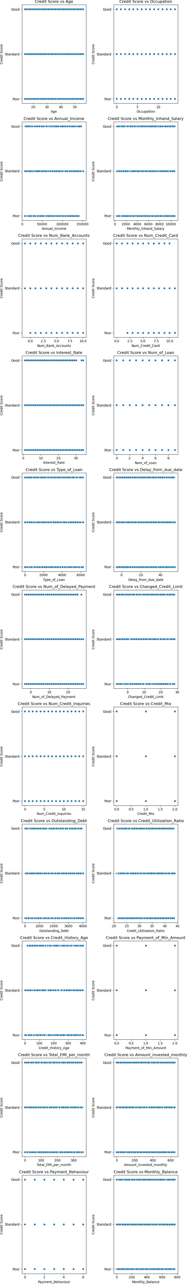

## EDA using visuals

Use (minimum) 2 plots (pair plot, heat map, correlation plot, regression plot...) to identify the optimal set of attributes that can be used for classification.

Name them, explain why you think they can be helpful in the task and perform the plot as well. Unless proper justification for the choice of plots given, no credit will be awarded.

In [104…

"""

Correlation plots (to identify the optimal set of attributes that can be used for classification. """

*# columns=new_df_for_processing[["Monthly_Inhand_Salary","Num_Bank_Accounts","Num_Credit_Card","Interest_Rate",*

columns **=** new_df_for_processing

correlation_matrix **=** columns**.**corr(numeric_only**=True**) plt**.**figure(figsize**=**(15, 8))

sns**.**heatmap(correlation_matrix, annot**=True**, cmap**=**'coolwarm', fmt**=**".2f")

plt**.**show()

"""

Why we choose this ? """

print('''

Identifying Relationships : Using correlation plots, we will be able to understand the relation between the att

Feature Selection: In predictive modeling tasks, it's essential to select features (independent variables) that are highly correlated with the target variable and can be useful for feature selection.

Model Interpretation: Understanding the correlations between variables can aid in interpreting the results of p ''')

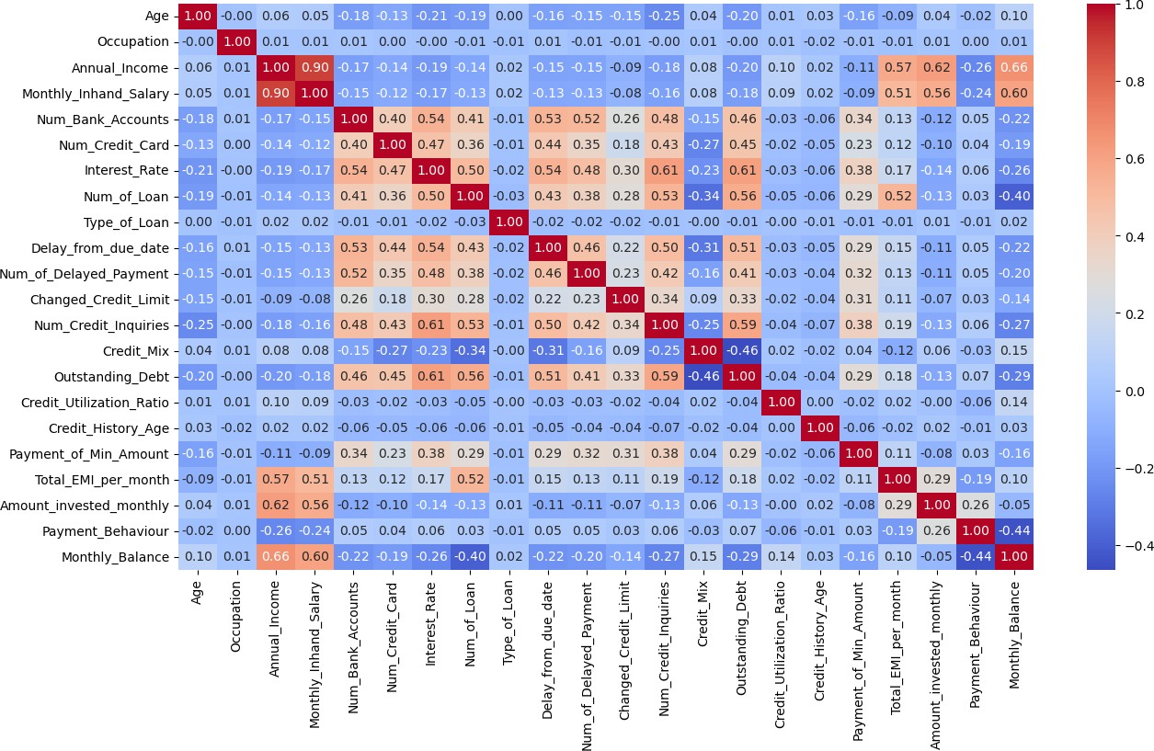

Identifying Relationships : Using correlation plots, we will be able to understand the relation between the att

ributess

Feature Selection: In predictive modeling tasks, it's essential to select features (independent variables) that are most relevant to the target variable. Correlation plots provide insights into which features

are highly correlated with the target variable and can be useful for feature selection.

Model Interpretation: Understanding the correlations between variables can aid in interpreting the results of p redictive models. It helps in understanding which features are driving the predictions and how they relate to e ach other

In [105…

g **=** sns**.**pairplot(columns)

print('''

1. Why we choose Pair plot ?
   1. EDA : Pair plots provide a visual summary of the dataset's structure and allow analysts to gain insights into relationships between variables.
   2. Identifying Patterns: Pair plots help in identifying patterns and trends in the data.

they can reveal linear or non-linear relationships between variables, clusters of data points, or outliers.

* 1. Multivariate Analysis: Pair plots facilitate multivariate analysis by allowing us to examine the interaction between multiple variables at once

''')

In [31]:

1. Why we choose Pair plot ?
   1. EDA : Pair plots provide a visual summary of the dataset's structure and allow analysts to gain insights into the data distribution and

relationships between variables.

* 1. Identifying Patterns: Pair plots help in identifying patterns and trends in the data.

they can reveal linear or non-linear relationships between variables, clusters of data points, or outliers.

* 1. Multivariate Analysis: Pair plots facilitate multivariate analysis by allowing us to examine the interaction s

between multiple variables at once

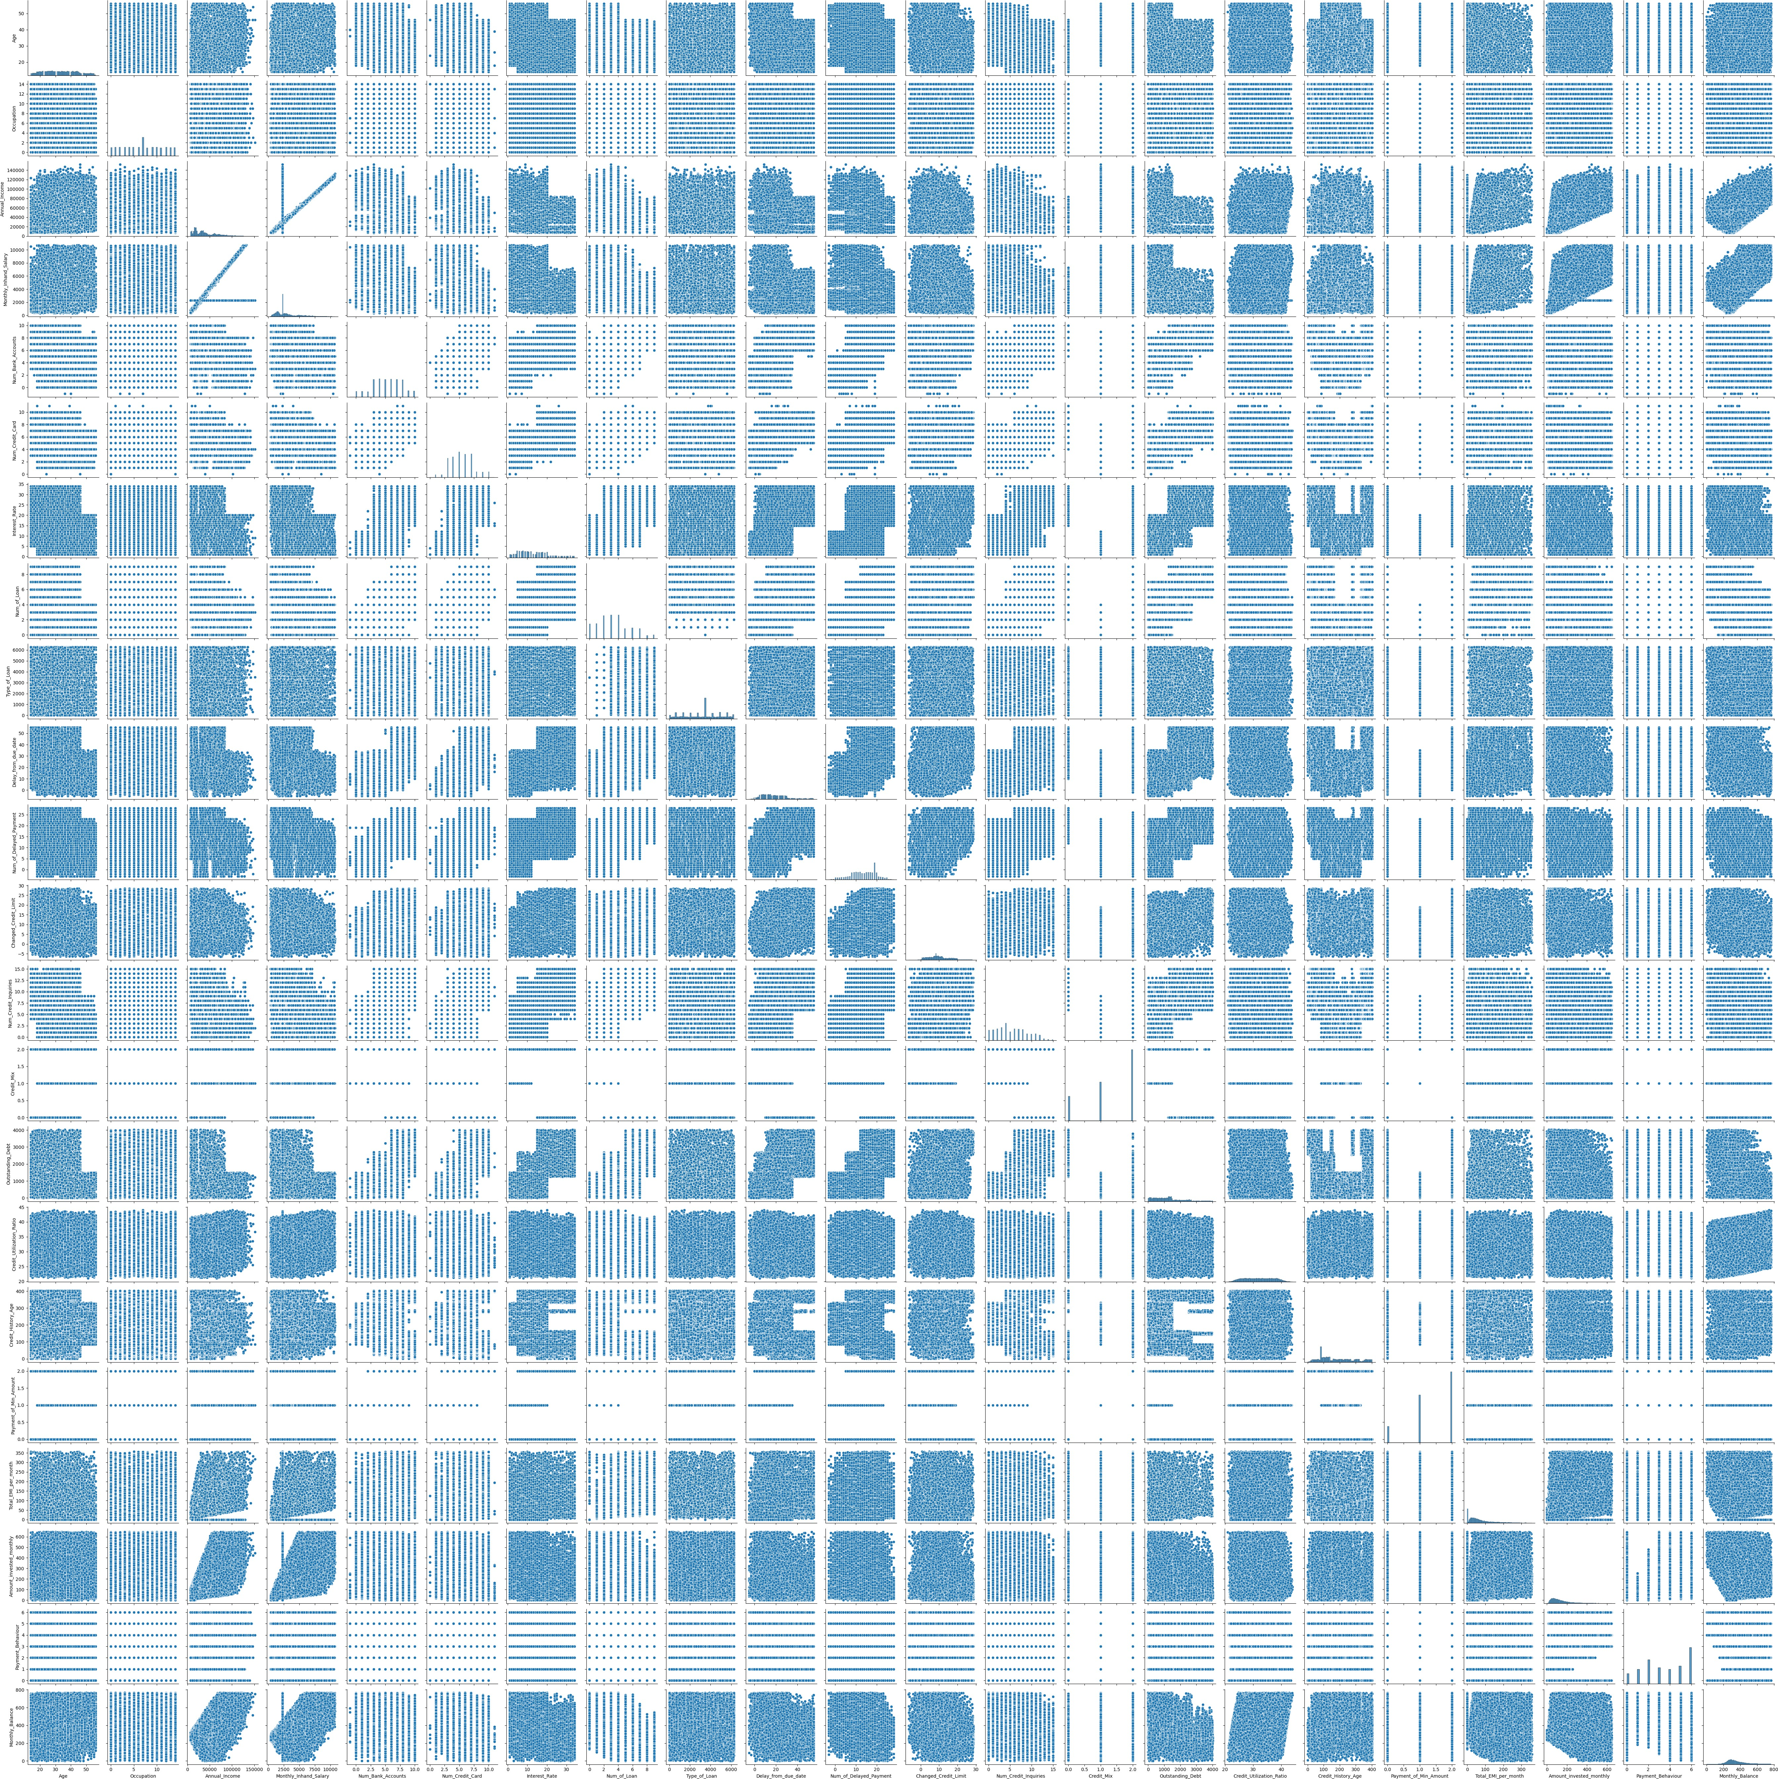

EDA FOR AGE GROUP

print('EDA FOR AGE GROUP')

new_df_for_processing['Age']**.**describe()

print('In the above output, max Age is 56, so we can have the bin max value around 60 number') bin_size **=** [10, 20, 30, 40, 50, 60]

labels **=** ['10-19','20-29', '30-39', '40-49', '50-59']

new_df_for_processing['Age_Bucket'] **=** pd**.**cut(new_df_for_processing['Age'], bins**=**bin_size, labels**=**labels) new_df_for_processing['Age_Bucket']**.**unique()

In the above output, max Age is 56, so we can have the bin max value around 60 number

/var/folders/mc/tvmqftjs65b9c9tt8m4d3y680000gn/T/ipykernel_12556/2301022899.py:6: SettingWithCopyWarning: A value is trying to be set on a copy of a slice from a DataFrame.

Try using .loc[row_indexer,col_indexer] = value instead

See the caveats in the documentation: https://pandas.pydata.org/pandas-docs/stable/user_guide/indexing.html#ret urning-a-view-versus-a-copy

new_df_for_processing['Age_Bucket'] = pd.cut(new_df_for_processing['Age'], bins=bin_size, labels=labels)

Out[31]: ['20-29', '50-59', '30-39', '40-49', '10-19']

Categories (5, object): ['10-19' < '20-29' < '30-39' < '40-49' < '50-59']

In [32]:

plt**.**figure(figsize**=**(15, 12))

sns**.**countplot(x**=**'Age_Bucket', data**=**new_df_for_processing, palette**=**'rainbow', order**=**new_df_for_processing['Age_B plt**.**xticks(rotation**=**45)

plt**.**xlabel('Age_Bucket') plt**.**ylabel('Count') plt**.**title('Age Counts')

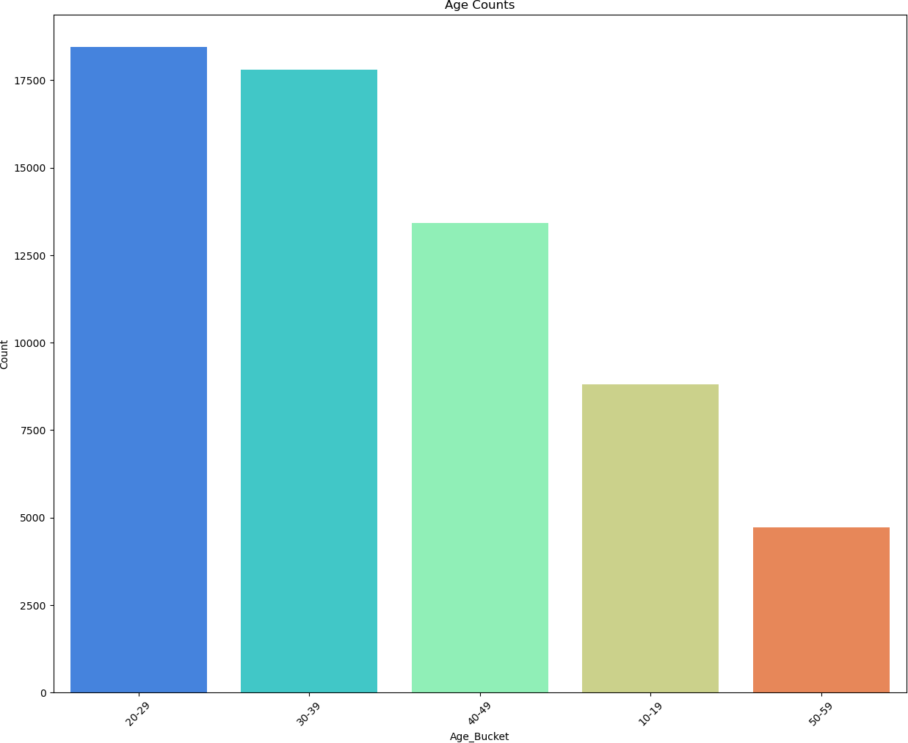Out[32]: Text(0.5, 1.0, 'Age Counts')

# Data Wrangling

## Univariate Filters

Numerical and Categorical Data

Identify top 5 significant features by evaluating each feature independently with respect to the target/other variable by exploring

. Mutual Information (Information Gain)

. Gini index

. Gain Ratio

. Chi-Squared test

. Strenth of Association

In [33]:

new_df_for_processing**.**select_dtypes('number')

Out[33]: Age Occupation Annual_Income Monthly_Inhand_Salary Num_Bank_Accounts Num_Credit_Card Interest_Rate Num_

0 23.0000000

1 23.0000000

2 23.0000000

3 23.0000000

4 23.0000000

... ...

98295 29.0000000

98297 38.0000000

98299 38.0000000

98300 38.0000000

12 19114.1200000

12 19114.1200000

12 19114.1200000

12 19114.1200000

12 19114.1200000

... ...

5 34599.9400000

7 41015.5500000

7 41015.5500000

7 41015.5500000

1824.8433333

2295.0583333

2295.0583333

2295.0583333

1824.8433333

... 2942.3283333

2295.0583333

3152.9625000

3152.9625000

3

3

3

3

3

... 7

0

0

0

4

4

4

4

4

... 6

4

4

4

3 4.

3 4.

3 4.

3 4.

3 4.

...

3 0.

4 1.

4 1.

4 1.

98301 38.0000000 7 41015.5500000 3152.9625000 0 4 4 1.

63207 rows × 22 columns

In [34]:

*##---------Type the code below this line ##*

"""

Mutual Information (Information Gain):

"""

**from** sklearn.feature_selection **import** mutual_info_classif

X **=** new_df_for_processing**.**select_dtypes('number')*# Replace "target_variable" with the actual column name*

y **=** new_df_for_processing["Credit_Score"] mutual_info **=** mutual_info_classif(X, y)

*# Create a DataFrame to display feature importance*

mi_df **=** pd**.**DataFrame({"Feature": X**.**columns, "Mutual_Information": mutual_info}) mi_df **=** mi_df**.**sort_values(by**=**"Mutual_Information", ascending**=False**)

print(f"Top 5 : \n\n {mi_df**.**head(5)}")

Top 5 :

Feature Mutual_Information

2 Annual_Income 0.6093724

14 Outstanding_Debt 0.6033751

18 Total_EMI_per_month 0.5489032

3 Monthly_Inhand_Salary 0.4867004

8 Type_of_Loan 0.3335940

In [35]:

*## GINI INDEX*

**from** sklearn.tree **import** DecisionTreeClassifier

X **=** new_df_for_processing**.**select_dtypes('number') y **=** new_df_for_processing["Credit_Score"]

clf **=** DecisionTreeClassifier(random_state**=**42) clf**.**fit(X, y)

*# Create a DataFrame to display feature importance*

gini_df **=** pd**.**DataFrame({"Feature": X**.**columns, "Gini_Index": clf**.**feature_importances_}) gini_df **=** gini_df**.**sort_values(by**=**"Gini_Index", ascending**=True**)

print(gini_df**.**tail(5))

Feature Gini_Index

15 Credit_Utilization_Ratio 0.0551538

6 Interest_Rate 0.0582164

16 Credit_History_Age 0.0637149

13 Credit_Mix 0.1285448

14 Outstanding_Debt 0.1797593

## Report observations

Write your observations from the results of each method. Clearly justify your choice of the method.

In [36]:

*##---------Type the code below this line ##*

"""

Observation based on Mutual """

'''

* A higher Mutual Information score for "Annual_Income" suggests that it contains a significant amount of infor
* The Mutual Information score for "Total_EMI_per_month" suggests that the total EMI (Equated Monthly Installme
* While "Monthly_Inhand_Salary" has a lower Mutual Information score compared to the previous features, it stil '''

"""

Observation based on gini index """

'''

Gini index measures the impurity of a split in a decision tree. Lower Gini index values indicate that the featu So , we have displayed top 5 recommendations from these techniques

'''

Out[36]: '\nGini index measures the impurity of a split in a decision tree. Lower Gini index values indicate that the fe ature is better at splitting the data into pure classes\nSo , we have displayed top 5 recommendations from thes

e techniques\n\n'

# Implement Machine Learning Techniques

Use any 2 ML tasks

. Classification

. Clustering

. Association Analysis

. Anomaly detection

You may use algorithms included in the course, e.g. Decision Tree, K-means etc. or an algorithm you learnt on your own with a brief explanation. A clear justification have to be given for why a certain algorithm was chosen to address your problem.

## ML technique 1 + Justification

In [68]:

*##---------Type the code below this line ##*

**import** pandas **as** pd

**from** sklearn.ensemble **import** RandomForestClassifier

**from** sklearn.model_selection **import** train_test_split

**from** sklearn.metrics **import** accuracy_score,precision_score,f1_score,recall_score,confusion_matrix,roc_curve, au

"""

Using scikit-learn (sklearn), we are performing splits on a dataset into two subsets:

1. one for training a machine learning model
2. Second one for testing its performance. """

y **=** new_df_for_processing['Credit_Score']

X **=** new_df_for_processing**.**drop(['Credit_Score','Occupation_Copy','Age_Bucket','Credit_History_Age','Num_of_Loan

*# X = new_df_for_processing.drop(['Credit_Score','Occupation_Copy','Age_Bucket'], axis=1)*

X_train, X_test, y_train, y_test **=** train_test_split(X, y, test_size**=**0.2, random_state**=**42)

In [ ]:

*##-----JUSTIFICATION---##*

"""

* RandomForestClassifier can handle mixed data types,

including both numeric and categorical features, which are present in the provided dataset (e.g., Occupation, T making it convenient to use with datasets containing diverse data type

* RandomForestClassifier Provides us high Accuracy compare to other techniques

Implicit Feature Selection: RandomForestClassifier automatically performs feature selection by considering a su like the provided one

* High Performance: RandomForestClassifier is known for its high performance and scalability, making it suitable for large datasets with many features and observations.

It can efficiently handle both classification and regression tasks """

In [59]:

"""

Random Forest Classifier Approach """

ml_tech_name **=** "Random Forest Classifier" rf_params **=** {

'max_depth': **None**, 'min_samples_split': 2,

'n_estimators': 200

}

model_rf **=** RandomForestClassifier(**\*\***rf_params) model_rf**.**fit(X_train, y_train)

y_pred_rf **=** model_rf**.**predict(X_test)

accuracy_rf **=** accuracy_score(y_test, y_pred_rf)

precision_rf **=** precision_score(y_test, y_pred_rf, average**=**'weighted') recall_score_rf **=** recall_score(y_test, y_pred_rf, average**=**'weighted') f1_score_rf **=** f1_score(y_test, y_pred_rf, average**=**'weighted')

print(f"Results of {ml_tech_name} \n Accuracy Score :{accuracy_rf} \n Precision Score : {precision_rf} \n Recal cm_rf **=** confusion_matrix(y_test, y_pred_rf)

plt**.**figure(figsize**=**(8, 6))

sns**.**heatmap(cm_rf, annot**=True**, fmt**=**"d", cmap**=**"Blues", xticklabels**=**model_rf**.**classes_, yticklabels**=**model_rf**.**class plt**.**xlabel("Predicted Class")

plt**.**ylabel("True Class")

plt**.**title(f"{ml_tech_name} Confusion Matrix \nAccuracy: {accuracy:.2f}") plt**.**show()

Results of Random Forest Classifier Accuracy Score :0.7963929757949691 Precision Score : 0.796716685568588 Recall_Score: 0.7963929757949691

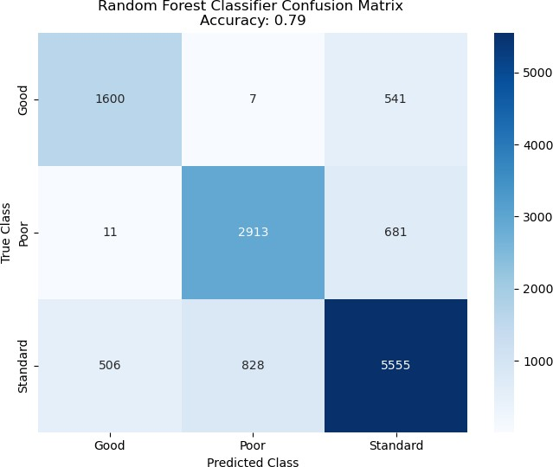F1_score: 0.7964328504372917

## ML technique 2 + Justification

In [71]:

*##---------Type the code below this line ##*

**from** sklearn.ensemble **import** GradientBoostingClassifier ml_tech_name **=** "Gradient Boosting"

*# Define the model parameters*

gb_params **=** {

'n_estimators': 100,

'learning_rate': 0.1,

'max_depth': 3

}

*# Initialize the GradientBoostingClassifier*

model_gb **=** GradientBoostingClassifier(**\*\***gb_params)

*# Fit the model to the training data*

model_gb**.**fit(X_train, y_train)

*# Make predictions on the testing data*

y_pred_gb **=** model_gb**.**predict(X_test)

accuracy_gb **=** accuracy_score(y_test, y_pred_gb)

precision_gb **=** precision_score(y_test, y_pred_gb, average**=**'weighted') recall_score_gb **=** recall_score(y_test, y_pred_gb, average**=**'weighted') f1_score_gb **=** f1_score(y_test, y_pred_gb, average**=**'weighted')

*# accuracy_gb = accuracy_score(y_test, y_pred_gb)*

*# print(f"Gradient Boosting Model Accuracy: {accuracy_gb}")*

print(f"Results of Gradient Boosting Model Accuracy \n Accuracy Score :{accuracy_gb} \n Precision Score: {preci cm_gb **=** confusion_matrix(y_test, y_pred_gb)

plt**.**figure(figsize**=**(8, 6))

sns**.**heatmap(cm_gb, annot**=True**, fmt**=**"d", cmap**=**"Greens", xticklabels**=**model_gb**.**classes_, yticklabels**=**model_gb**.**clas plt**.**xlabel("Predicted Class")

plt**.**ylabel("True Class")

plt**.**title(f"{ml_tech_name} Confusion Matrix \nAccuracy: {accuracy_gb:.2f}") plt**.**show()

In [ ]:

*##-----JUSTIFICATION FOR GradientBoostingClassifier---##*

"""

-GradientBoostingClassifier can handle mixed data types, including both numeric and categorical features, prese making it convenient to use with datasets containing diverse data types.

-GradientBoostingClassifier is an ensemble learning method that builds a sequence of decision trees sequentiall with each tree attempting to correct the errors of its predecessor.

-GradientBoostingClassifier provides feature importance scores, which indicate the contribution of each feature predictive performance.

- Provides comparatively good Accuracy for the choosen dataset """

Results of Gradient Boosting Model Accuracy Accuracy Score :0.7410219901914255

Precision Score: 0.7484218989734007

Recall_Score: 0.7410219901914255

F1_score: 0.7430249143666638

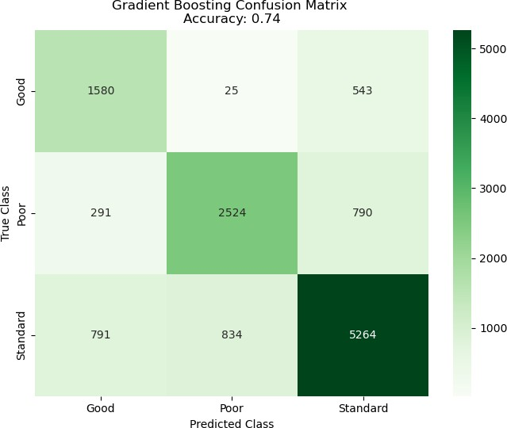

## Conclusion

Compare the performance of the ML techniques used.

Derive values for preformance study metrics like accuracy, precision, recall, F1 Score, AUC-ROC etc to compare the ML algos and plot them. A proper comparision based on different metrics should be done and not just accuracy alone, only then the comparision becomes authentic. You may use Confusion matrix, classification report, Word cloud etc as per the requirement of your application/problem.

In [66]:

*##---------Type the code below this line ##*

**import** matplotlib.pyplot **as** plt

*# Define performance metrics for Gradient Boosting*

gb_metrics **=** {

'Accuracy': accuracy_gb, 'Precision': precision_gb, 'Recall': recall_score_gb, 'F1 Score': f1_score_gb

}

*# Define performance metrics for Random Forest*

rf_metrics **=** {

'Accuracy': accuracy_rf, 'Precision': precision_rf, 'Recall': recall_score_rf, 'F1 Score': f1_score_rf

}

*# Metrics and corresponding labels* metrics **=** list(gb_metrics**.**keys()) gb_values **=** list(gb_metrics**.**values()) rf_values **=** list(rf_metrics**.**values())

*# Plotting*

x **=** range(len(metrics)) plt**.**figure(figsize**=**(10, 6))

plt**.**bar(x, gb_values, width**=**0.4, label**=**'Gradient Boosting', color**=**'skyblue', align**=**'center') plt**.**bar(x, rf_values, width**=**0.4, label**=**'Random Forest', color**=**'lightcoral', align**=**'edge')

plt**.**xlabel('Performance Metrics') plt**.**ylabel('Scores')

plt**.**title('Comparison of Performance Metrics: Gradient Boosting vs. Random Forest') plt**.**xticks(x, metrics)

plt**.**legend() plt**.**show()

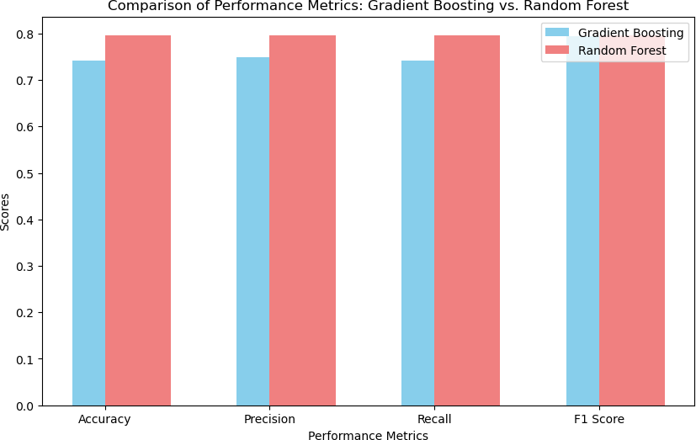

Accuracy: Random Forest Classifier has a higher accuracy score compared to Gradient Boosting (0.796 vs. 0.741). Higher accuracy indicates that

Random Forest Classifier has made more correct predictions overall. Precision: Random Forest Classifier also has a slightly higher precision score compared to Gradient Boosting (0.797 vs. 0.748). Precision measures the proportion of true positive predictions among all positive predictions. A higher precision indicates fewer false positives. Recall: Random Forest Classifier has a higher recall score (0.796) compared to Gradient Boosting (0.741). Therefore, based on the recall score alone, the Random Forest Classifier appears to perform better in terms of identifying positive samples. It is able to correctly identify a larger proportion of actual positive cases compared to the Gradient Boosting model. F1 Score: Random Forest Classifier has a slightly higher F1 score compared to Gradient Boosting (0.796 vs. 0.743). F1 score is the harmonic mean of precision and recall and is a good measure of a model's overall performance.

## Solution

## Q) What is the solution that is proposed to solve the business problem discussed in

Section 1. Response) As per the business problem we wanted to solve is to analyse the customer credit history and financial attributes to calculate the risk factor to provide loan to a customer. Our models helps us predict and classify a customer as Good, standard and poor, based on his historical data, based on which one can decide if the customer is eligible for loan application approval. Q) Learnings while working through solving the problem in terms of challenges, observations, decisions CHALLENGES - When workings with large dataset which has multiple features, we found cleaning up data was big challenge. - Had difficulties to identify the required feature for computation and prediction analysis. - Learning the methods available in scikit learning was bit challenging. - Had difficulties in identifying suitable model for the chosen dataset to get better accuracy.

OBSERVATION - Understood how the Mutual Information (Information Gain) and Gini index helped us in identifying the important features. - Understood how different parameters of the models are affecting the prediction accuracy. DECISIONS - We had to drop few columns in the data Frame based on Gini and Mutual information output for better precision and accuracy.